TECHNICAL PROJECT REPORT

# Title of Invention / Project: Room Head Count Display

# Team Members / Inventors:

|  |  |  |  |  |  |
| --- | --- | --- | --- | --- | --- |
| **S.No.** | **Name** | **Department** | **Designation** | **Mobile** | **E-Mail** |
| 1. | D.MD.Arsalan | CSE AI & ML | Student | 8897250816 | dmarsalan@gmail.com |
| 2. | Arnab Dey | CSE AI & ML | Student | 7797366638 | my.arnabdey001@gmail.com |
| 3. | Subham Agarwal | CSE AI & ML | Student | 7082334898 | subhamaga@gmail.com |
| 4. | Arunabha Mondal | CSE AI & ML | Student | 8436486250 | arunabham5@gmail.com |
| 5. | Bhavesh Nazwani | CSE AI & ML | Student | 8755385375 | bhaveshnazwani2@gmail.com |
| 4. | Khushal Thakur | ECE | Mentor | 9646030764 | khushal.thakur@cumail.in |
| 5. | Anshul Sharma | ECE | Mentor | 9478697475 | anshulsharma.ece@cumail.in |
| 6. | Kiran Jot Singh | ECE | Mentor | 9463909689 | kiranjotsingh.ece@cumal.in |
| 7. | Divneet Singh Kapoor | ECE | Mentor | 9878422653 | divneet.ece@cumail.in |

**SECTION-1(IPR Related)**

**BRIEF ABSTRACT:**

Many seminars and meetings take place regularly around this world. They have the problem of keeping a record of how many people have attended the seminars or the exibitions. Many convenctional settings are used like making a entry in the book while entering the room or buying the tickets while entering . But it becomes difficult if the crowd is high, to maintain the record. Many ideas have been generated in oder to solve these.People have tried to overcome these problems using a few specific sensors,the data stored can further be used to analyse the time when people visit the place the most.

**HOW ARE WE SOLVING THE PROBLEM?**

We are using the room head counter system to overcome this problem.Our system uses sensors like PIR(passive infrared sensor),Aurdino to detect the motion and count the people . It is the automated solution to convenctional counting solutions, that would make the method of storing and analysing data easier.This PIR motion sensor uses heat reading systems to detect the motion. The motion sensor detects and counts the people entering and exiting the room.

**ADDITIONAL MODIFICATIONS THAT CAN CATER TO IMPROVED SOLUTION:**

* This system could be mde with the help of bluetooth reciver for lcd so to make long distance transfer easy.
* This can be made cost effective with the expertise in coding by making a code for more PIR’s with one microcontroller.
* Iot devices can be used to store the data to the cloud and be analysed for further uses .

# Existing state-of-the-art and Drawbacks in existing state-of-the-art

|  |  |  |
| --- | --- | --- |
| **S. No.** | **Existing state of art** | **Drawbacks in existing state of art** |
| 1 | MOTION DETECTION SYSTEM  (US6163025A) | * Detects motion using IR sensor that just detects the motion and doesn’tt count the data . |

Novel/Additional modifications that you can propose to improve upon drawbacks:

* Instead of using the breaboard connections to arduino it can be using bluetooth for large halls which has more no. Of entry and exit gates.
* Using the system for school purpose (ie) for attendance marking .
* Can be clubbed with alarm system to see how many attempts have been made to break in and breach the security, and increase wherever required.

# **Advantages:**

* It will reduce the workforce required to count and analyse the persons visiting the venue.
* It would make easier , deciding on when and how the presons would visit the venue.
* Counter would help prevent the disturbance caused due to conventional counting system and increase the efficiency.

**BLOCK DIAGRAM**

LCD 2

LCD 1

EXIT LOOP

ENTRY LOOP

ARDUINO UNO 2

ARDUINO UNO 1

**SECTION-2(REAL PROJECT)**

**MATERIALS:**

|  |  |  |
| --- | --- | --- |
| **MATERIALS** | **PIECE** | **COST EACH** |
| **ADRUINO UNO** | **2** | **420** |
| **PIR SENSOR** | **2** | **170** |
| **JUMPER WIRE** | **60** | **03** |
| **LCD** | **2** | **145** |
| **POTENTIOMETER** | **2** | **50** |
| **BREADBOARD** | **2** | **125** |

**CIRCUIT DIAGRAM**

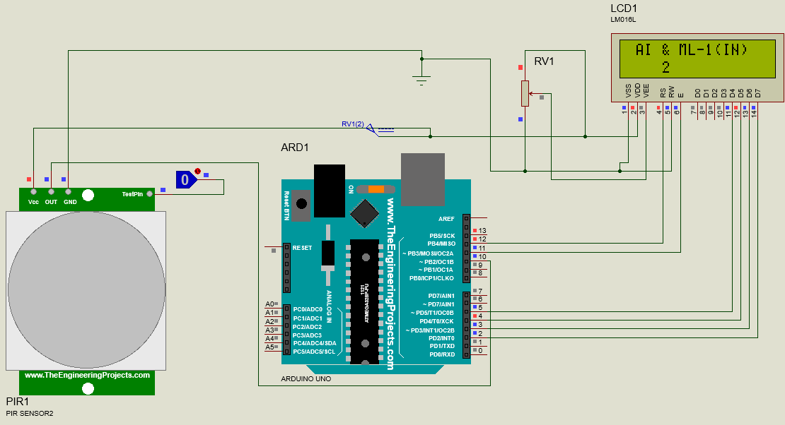

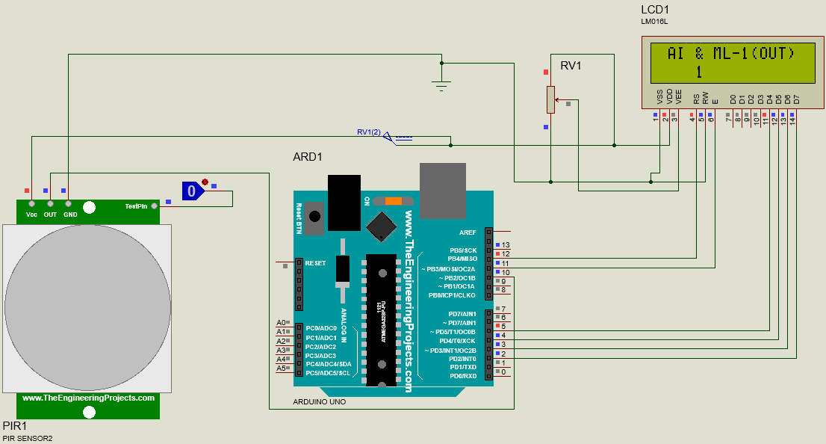

**STEPS OF CIRCUIT COMPLETION:**

It was not an easy task to complete our project as it consisted of complexities like PIR SENSOR with LCD and ADRUINO and never the less. We had to go through a lot of difficult steps for our Circuit Completion:

1. Gathering all the material required for the circuit which included visiting electronics shop again and again as per the availability of different devices.

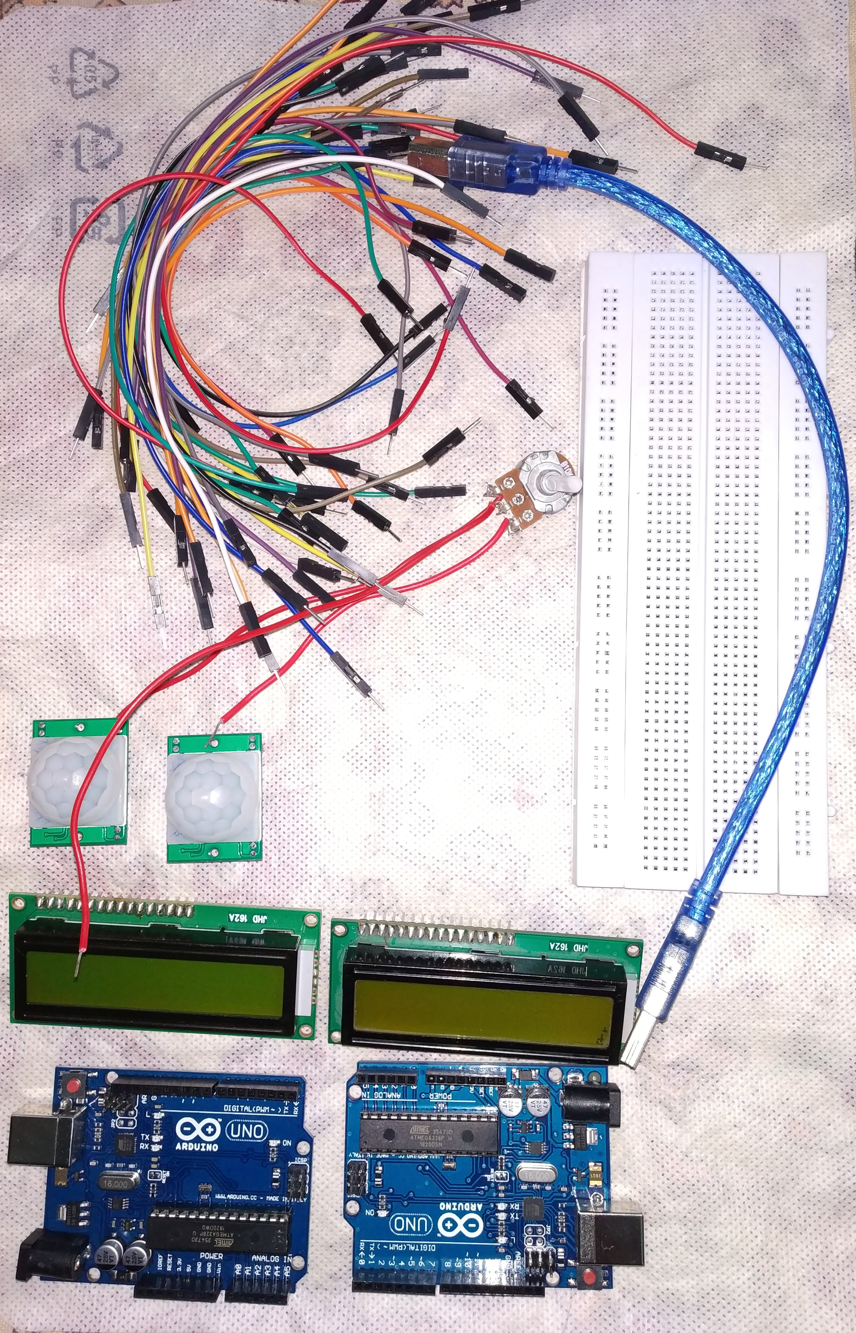

1. After learning about how to make connections, circuit formation started with connecting Arduino with different devices and breadboard.

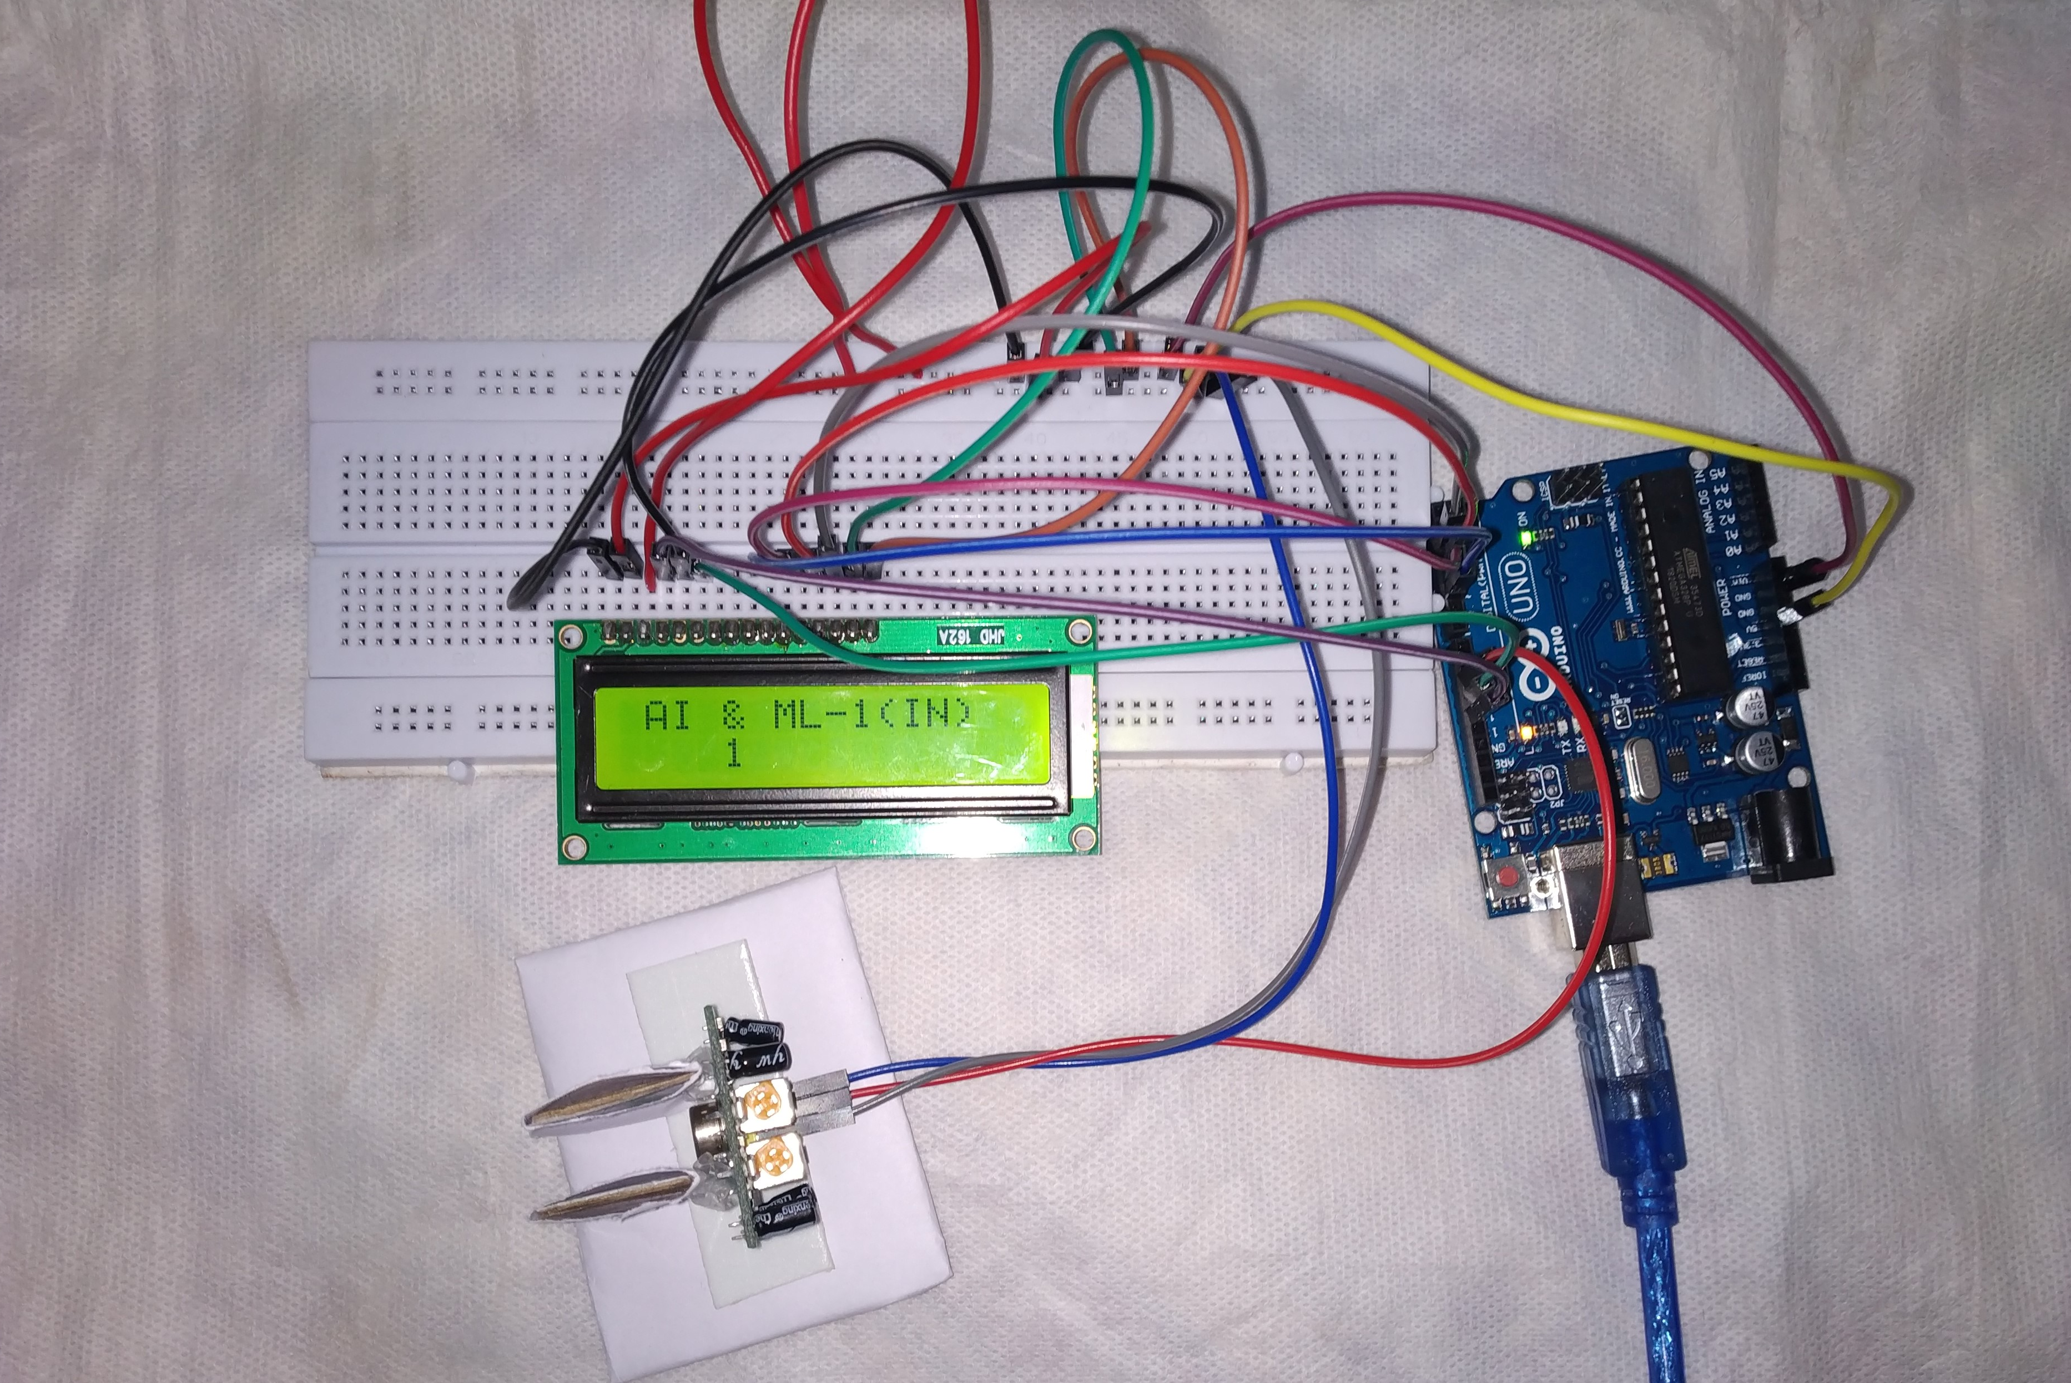

1. Successful connection of LCD with Arduino,PIR sensor , lcd .
2. Veifing working of circuit 1



1. Verifing working ouf circuit 2

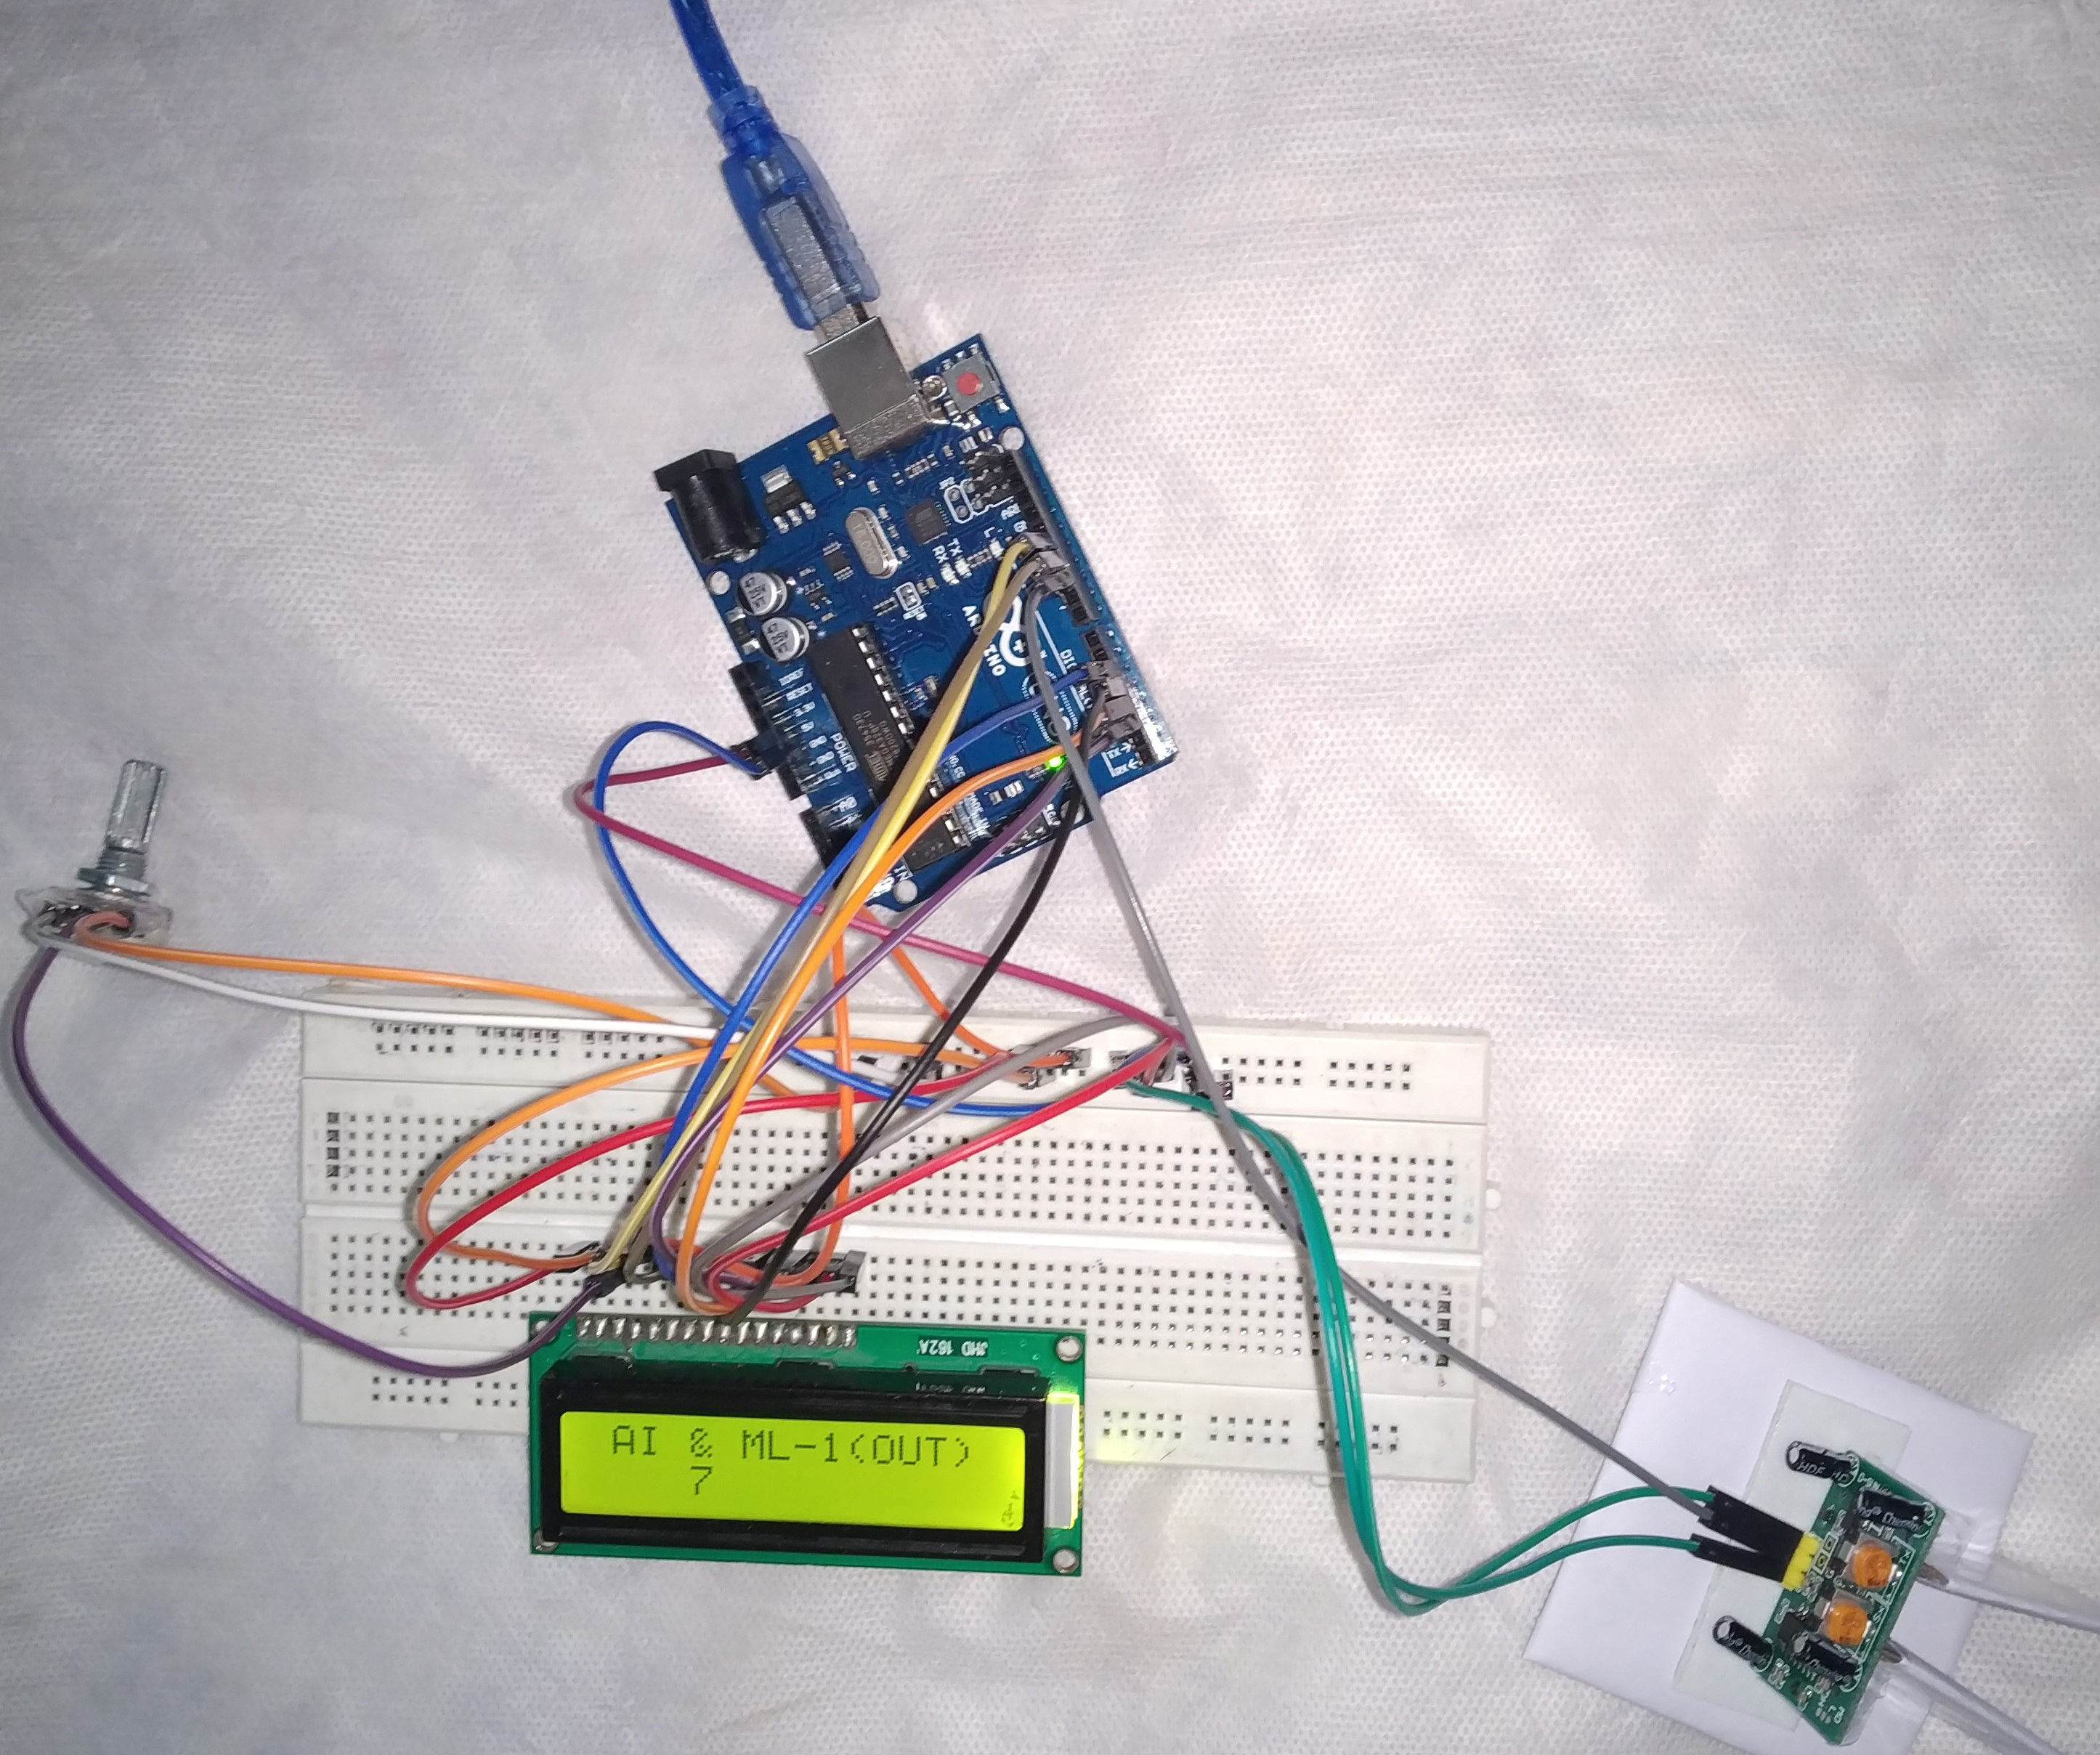

1. Working of both the circuit simultaneously.
2. Final product.

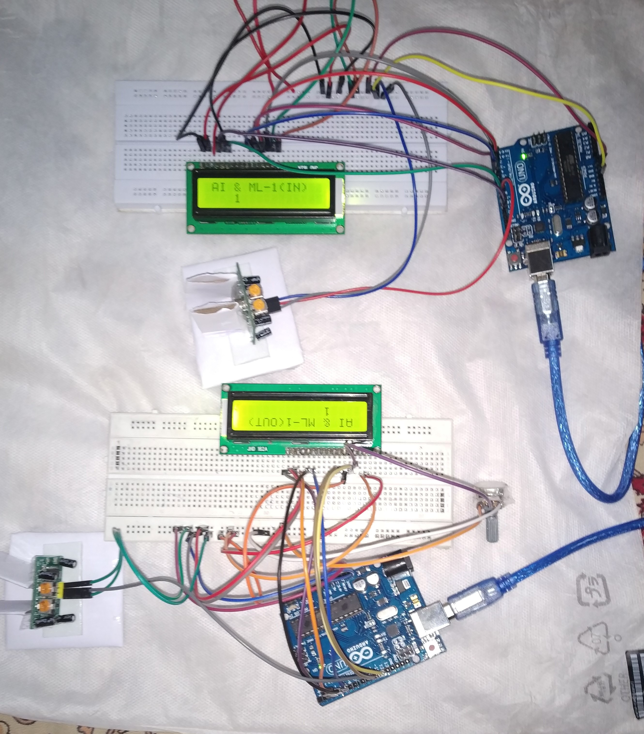

**PROBLEMS FACED :**

1. **PIR SETTING WAS DIFFICULT AS IT HAD LONG RANGE AND DELAY.**
2. **LCD CIRCUIT WAS NOT WORKINF FINE AND WE HAD TO REPEAT THE PROCESS SEVERAL TIMES TO MAKE IT WORK.**
3. **CODING FOR TWO LOOP WERE WORKING FINE , BUT FOR SINGLE ARDUINO WITH TWO PIR WASNT SUPPORTING THE CODE.**
4. **EACH PIR HAD DIFFERENT SETTINGS.WHICH TOOK LONG TIME TO SETTINGS.**

**CODING**

**PROGRAM CODE:** 